Tutorial mastering-nuxt-3

# 1-0 Getting Set Up

In this lesson, you’ll get set up to start working on the Mastering Nuxt 3 codebase.

We’ll download the code, install pnpm and nuxi, and see how we can use git to checkout the code from a specific lesson.

Update, March 2023: Only the most recent commits are shown when running git log, so you may need to scroll down (using the mouse wheel, enter, or space bar) in order to see the first commits.

pnpm: <https://pnpm.io>

Fig: <https://fig.io>

# 1-1 File based routing

In this lesson, we’ll learn how to use Nuxt to create routes in our app. We’ll see how Nuxt automatically turns our files and directories into routes using Vue Router.

TailwindCSS: <https://tailwindcss.com>

Tailwind Prose plugin: <https://tailwindcss.com/docs/typography-plugin>

NuxtTailwind: <https://tailwindcss.nuxtjs.org>

Nuxt 3 tự động tạo route path theo cấu trúc trong thư mục pages.

Mặc định **pages** là thư mục gốc.

|  |  |
| --- | --- |
|  |  |

# 1-2 Displaying Course Lessons

In this lesson, we figure out how we want to set up our routes in order to show course lessons. We’ll discuss what makes a good route, and outline how we’ll implement it.

* first-chapter, second-lesson: is dinamic route
* soucre/chapter/lesson: is not dinamic route

# 1-3 Nested Routes

In this lesson, we’ll learn how we can use nested routes to create powerful app hierarchies. We’ll separate out the logic for displaying a lesson into it’s own child page.

**Example**: course/lesson; **course** is parent, **lesson** is children (nested route).

**app.vue**

**pages/course.vue**

**course/lesson.vue**

**Summary to create nested route**

* course: course.vue, folder course.
* lesson: course/lesson.vue.

# 1-4 Dynamic Routes

In this lesson, we’ll explore dynamic routes in Nuxt. This will let us navigate to any chapter and lesson in our course. We’ll also see all the different ways we can use dynamic routes to create complex routing.

## Example 1

**Do example 1**

Từ file lesson.vue, thay đổi tên file bằng:

Sau đó ấn enter, được kết quả:

Truy cập từ URL

We can access params url:

## Example 2

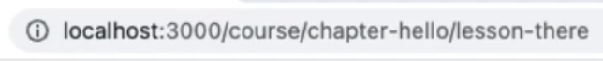

**Do example 2**

Từ file course/lesson.vue, thay đổi tên file bằng:

Sau đó ấn enter, được kết quả:

Truy cập từ URL

## Example 3

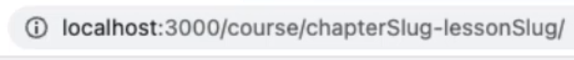

## Example 4

Truy cập URL với tham số tùy chọn [[lessonSlug]]

Truy cập từ URL

**Vue devtool route**

# 1-5 Loading in Course Data

In this lesson, we’ll hook up some actual data so we have something more substantial to work with. We’ll also see how to use nuxi to generate files for us.

nuxi: <https://v3.nuxtjs.org/api/commands/add>

Configuring auto-imports: <https://v3.nuxtjs.org/api/configuration/nuxt.config#imports>

## Create compatable

nuxi add composable useCourse

## Create data

## Import data to component

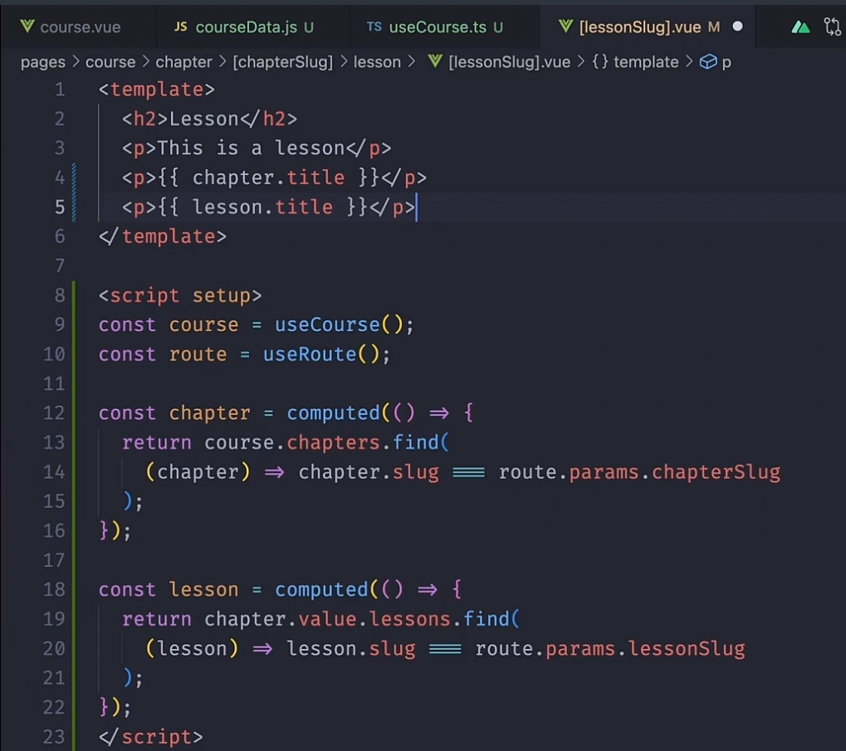

# 1-7 Add VideoPlayer Component